Banker’s Card:

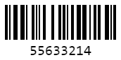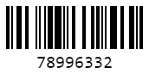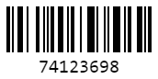Property actions:

Auction

Pay rent on

Buy

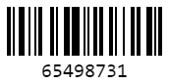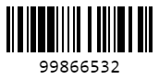Taxes:

Luxury Tax

Income Tax

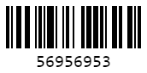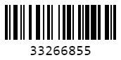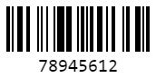Other Payments:

Build house/hotel

Pass go

Get out of jail

Checking balances:

Check Vault Balance

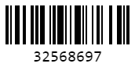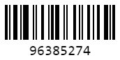

Check properties owned

Check Balance

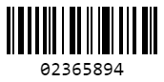

Custom Transactions: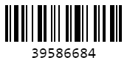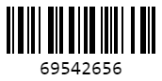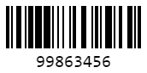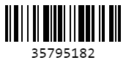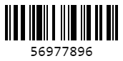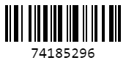

Bank to vault

Player to vault

Player to player

Player to bank

Bank to player

Buy property from player

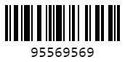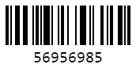

End game

Error

Other: